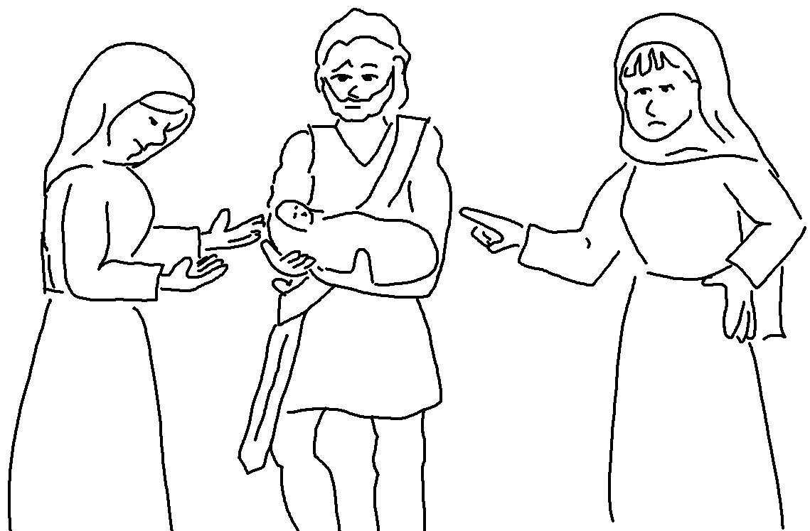

Respect and obey the Lord! This is the beginning of wisdom. Proverbs 9:10 _{CEV}

